BRIZTECH INFOSYSTEM PVT.LTD RANCHI



AN PROJECT SUBMITTED

IN PARTIAL – FULFILMENT OF THE REQUIREMENT

FOR THE AWARD OF THE DEGREE OF

DIPLOMA IN COMPUTER SCIENCE ENGINEERING

**Online Photo Editor**

**(FOR DEGREE OF DIPLOMA)**

**Submitted By :-SHREYA KUMARI SINGH**

**GOVERNMENT WOMEN’S POLYTECHNIC, JAMSHEDPUR-832108**

ACKNOWLEDGMENT

This thesis work has been an intellectually invigorating experience for me. I am sure that the knowledge and experience gathered during the course of this work will make me stand in good stead in future.

With immense pleasure and due respect I express my sincere gratitude to In charge, Ranchi COLLEGE GOVERNMENT WOMEN’S POLYTECHNIC JAMSHEDPUR, for all his support and co-operation in successfully completing this thesis work by providing excellent facilities.

I would also like to extend my sincere gratitude to all faculties’ members and staff for helping me in my college during my Bsc IT course.

I would like to take this opportunity to extend my sincere gratitude and thanks to my Pioneer **NEHA Ma’am ,**firstly for coming up with such an innovative thesis idea. He has not only made us to work but guided us to orient toward research. It has been real pleasure working under his guidance and it is chiefly his encouragement and motivation that has made this thesis a reality.

Last, but not the last I am heartily thankful to almighty God for showering his blessing forever during my entire life and also to my family members for providing me a great support.

**TRANING & PLACEMENT INCHARGE**  **(SHREYA KUMARI SINGH)**

CERTIFICATE FOR PROJECT

This is to certify that this is a bona fide record of the project work entitled **“Project”** done satisfactory at “GWP JAMSHEDPUR**”** by **SHREYA KUMARI SINGH**)**,** in partial fulfillment of DIPLOMA Examination.

This report or similar report on the topic has not been submitted for any other examination and doesn’t form part of any other course undergone by the candidate.

**INTERNAL GUIDE EXTERNAL GUIDE UNDER THE GUIDANCE OF - MR. KANCHAN RAJU**

# TABLE OF CONTENT

**Sr. No. Topic Page**

* 1. Introduction 9
  2. Hardware & Software Requirement 11
  3. Problem Identification 21
  4. Feasibility Study 23
  5. Requirement Analysis 27
  6. Review of Previous Work 30
  7. System Planning 31
  8. Design 32
     1. Source Code 35
     2. Screenshot 43
     3. Dataflow Diagram 54
  9. Conclusion & Future Work 55
  10. Refrences 56
  11. Biodata of Group Member 1 57

12. Biodata of Group Member 2 59

# Abstract

The project aims at developing an image editor using PHP and other Web development language. Image editor is a small application which lets the user to manipulate digital images using tools such as color adjustments, sharpening, zoom, rotation, print etc. Efficient GUI has been provided which let the user to access this tool.

Editor access the image in arrays of pixels. These pixels contain the image's color and brightness information. Image editor can change the pixels to enhance the image in many ways. The pixels can be changed as a group, or individually, by the algorithms within the image editors and imagefilters.

### Some Key Features are:

#### Image size alteration—

Image editors can resize images in a process often called image scaling, making them larger, or smaller. High image resolution cameras can produce large images which are often reduced in size for internet use. Image editor programs use a mathematical process called resampling to calculate new pixel values whose spacing is larger or smaller than the original pixel values.

### **Several types of filters are installed in the application:**

Like blur, sharpen, contrast, brightness, greyscale, invert color mask, RGB adjust, look up, ripple, twirl, oil, light, crystal.

* Working of some filters is shown:
* Crystal,invert color.
* Smoothen, oil.

#### Brush tool:

Brush stroke can be used for many things like for writing something, drawing, and also can be used for fixing minor blemishes.

Some basic features are also there in the application. Like:

1. Circle, line, rectangle, crop, paint fill etc.
2. Paint
3. Brightness and contrast
4. Color balance (autobalance)
5. Transparency.

#### Enhancing images-

In computer graphics, the process of improving the quality of a digitally stored image by manipulating the image with software. It is quite easy, for example, to make an image lighter or darker, or to increase or decrease contrast. Advanced photo enhancement software also supports

many filters for altering images in various ways. Programs specialized for image enhancement are sometimes called image editors.

#### Cutting out a part of an image from the background

Using a selection tool, the outline of the figure or element in the picture is traced selected, and then the background is removed. Depending on how intricate the "edge" is this may be more or less difficult to do cleanly. For example, individual hairs can require a lot of work.

#### Image Cropping—

Digital editors are used to crop image. Cropping creates a new image by selecting a desired rectangular portion from the image being cropped. The unwanted part of the image is discarded. Image cropping does not reduce the resolution of the area cropped. Best results are obtained when the original imagehas a high resolution. A primary reason for cropping is to improve the image composition in the new image.

#### Paint—

Paint is a special feature of image editors. It is a very userfriendly and easy Tool for painting your imagination on an image. You can select from various type of brushes, pencil, pens and use a lot of color from collection of colors.

#### Resizing—

Resizing is a special feature of image editor which helps to resize and alter the size of image

# INTRODUCTION

## IMAGE EDITOR-

Software that allows images to be edited and enhanced and also converted to different graphics formats. Image editors typically deal with only bitmapped **images** such as GIFs, JPEGs and BMPs; however, some editors support both bitmaps and illustrations.

Image editor provide many type of filters and effects, by using these filters and effect you can enhance the quality of image and using various type of Effect you can make your image very illustrative and artistic.

There is various type of filters are used for enhancing and modifying the quality of image and removing the noise from the image and blurring the images.

So, basically image editor is used to provide a better quality, enhanced and improved image with implementation of several effects and filters.

More things you can do with an image editor is that you can resize and crop the image. Flipping of image is also a feature of image editor. With the use of crop feature you can crop and cut the image of your desire.

An image editing application for digital photos. It is used to crop and touch up photos, as well as organize them into albums and slide shows. Photo editors typically do not have the myriad filters and features of a full-blown image editorsuch as Adobe's photoshop or corel's paint shop pro.

# **Hardware and Software Requirement**

### 

### **Hardware Requirements**:

1. Windows System
2. 512 MB RAM Minimum
3. Hard Drive and Storage Device

### **Software Requirement**:

1. PHP and MYSQL Server
2. Notepad ++ or Adobe Dreamweaver
3. Web Browser
4. Programming Languages: PHP, HTML, JAVA Script, CSS

### **Windows O/S:**

Microsoft Windows is a group of several graphical operating system families, all of which are developed, marketed, and sold by Microsoft. Each family caters to a certain sector of the computing industry. Active windows families include windows NT and windows embedded; these may encompass subfamilies, e.g. windows embedded compact (Windows CE) or windows server. Defunct windows families include windows 9x, windows Mobile and windows phone.

Microsoft introduced an operating environment named windows on November 20, 1985, as a graphical operating system shell for MS-DOS in response to the growing interest in graphical user interfaces (GUIs). Microsoft Windows came to dominate the world's personal computer (PC) market with over 90% market share, overtaking Mac OS, which had been introduced in 1984. Apple came to see windows as an unfair encroachment on their innovation in GUI development as implemented on products such as the Lisa and Macintosh (eventually settled in court in Microsoft's favor in 1993). On PCs, Windows is still the most popular operating system. However, in 2014, Microsoft admitted losing the majority of the overall operating system market to Android because of

the massive growth in sales of Android smartphones. In 2014, the number of windows devices sold was less than 25% that of Android devices sold. This comparison however may not be fully relevant, as the two operating systems traditionally target different platforms. Still, numbers for server use of Windows (that are comparable to competitors) show one third market share, similar to for end user use.

### **HTML:**

Hypertext Markup Language (HTML) is the standard markup language for creating web pages and web applications. With cascading style sheets (CSS) and JavaScript, it forms a triad of cornerstone technologies for the World Wide Web. Web browsers receive HTML documents from a web server or from local storage and render the documents into multimedia web pages. HTML describes the structure of a web page semantically and originally included cues for the appearance of the document.

HTML elements are the building blocks of HTML pages. With HTML constructs, images and other objects such as interactive forms may be embedded into the rendered page. HTML provides a means to create structured documents by denoting structural semantics for text such as headings, paragraphs, lists, links, quotes and other items. HTML elements are delineated by tags, written using angle brackets. Tags such as <image/> and <input/> directly introduce content into the page. Other tags such as <p>...</p> surround and provide information about document text and may include other tags as sub-elements. Browsers do not display the HTML tags, but use them to interpret the content of the page.

HTML can embed programs written in a scripting language such as JavaScript which affects the behavior and content of web pages, inclusion of CSS defines the look and layout of content.

### **JAVA Script:**

JavaScriptoften abbreviated as JS, is a high-level, interpreted programming language. It is a language which is also characterized as dynamic, weakly typed, prototype-based and multi-paradigm.

Alongside HTML and CSS, JavaScript is one of the three core technologies of the World Wide Web. It is used to make dynamic webpages interactive and provide online programs, including video games. The majority of websites employ it and all modern web browsers support it without the need for plug-ins by means of a built-in JavaScript engine. Each of the many JavaScript engines represent a different implementation of JavaScript, all based on the ECMAScript specification, with some engines not supporting the spec fully, and with many engines supporting additional features beyond ECMA.

As a multi-paradigm language, JavaScript supports event-driven, functional, and imperative (including object-oriented and prototype- based) programming styles. It has an API for working with text, arrays, dates, regular expressions, and basic manipulation of the DOM, but the language itself does not include any I/O, such as networking, storage, or graphics facilities, relying for these upon the host environment in which it is embedded.

Initially only implemented client-side in web browsers, JavaScript engines are now embedded in many other types of host software, including server-side in web servers and databases, and in non-web programs such as word processors and PDF software, and in runtime environments that make JavaScript available for writing mobile and desktop applications, including desktop widgets.

### **CSS:**

Cascading Style Sheets (CSS) is a style sheet language used for describing the presentation of a document written in a markup language. Although most often used to set the visual style of web pages and user interfaces written in HTML and XHTML, the language can be applied to any XML document, including plain XML, SVG and XUL, and is applicable to rendering in speech, or on other media. Along with HTML and JavaScript, CSS is a cornerstone technology used by most websites to create visually engaging webpages, user interfaces for web applications, and user interfaces for many mobile applications.

CSS is designed primarily to enable the separation of presentation and content, including aspects such as the layout, colors, and fonts. This separation can improve content accessibility, provide more flexibility and control in the specification of presentation characteristics, enable multiple HTML pages to share formatting by specifying the relevant CSS in a separate CSS file, and reduce complexity and repetition in the structural content.

Separation of formatting and content makes it possible to present the same markup page in different styles for different rendering methods, such as on-screen, in print, by voice (via speech-based browser or screen reader), and on Braille-based tactile devices. It can also display the web

page differently depending on the screen size or viewing device. Readers can also specify a different style sheet, such as a CSS file stored on their own computer, to override the one the author specified.

Changes to the graphic design of a document (or hundreds of documents) can be applied quickly and easily, by editing a few lines in the CSS file they use, rather than by changing markup in the documents.

The CSS specification describes a priority scheme to determine which style rules apply if more than one rule matches against a particular element. In this so-called cascade, priorities (or weights) are calculated and assigned to rules, so that the results are predictable.

### **PHP:**

Hypertext Preprocessor (or simply PHP) is a server-side scripting language designed for web development but also used as a general- purpose programming language. It was originally created by RasmusLeadoff in 1994, the PHP reference implementation is now produced by The PHP Group. PHP originally stood for Personal Home Page, but it now stands for the recursive acronym PHP: Hypertext Preprocessor.

PHP code may be embedded into HTML code, or it can be used in combination with various web template systems, web content management systems, and web frameworks. PHP code is usually processed by a PHP interpreter implemented as a module in the web server or as a Common Gateway Interface (CGI) executable. The web server combines the results of the interpreted and executed PHP code, which may be any type of data, including images, with the generated web page. PHP code may also be executed with a command-line interface (CLI) and can be used to implement standalone graphical applications.

The standard PHP interpreter, powered by the Zend Engine, is free software released under the PHP License. PHP has been widely ported

and can be deployed on most web servers on almost every operating system and platform, free of charge.

The PHP language evolved without a written formal specification or standard until 2014, leaving the canonical PHP interpreter as a de facto standard. Since 2014 work has gone on to create a formal PHP specification.

# Problem Identification

Although there are thousands of image editing software are available ondifferentplatform, but most of them provide only limited number of features and editing and illustration. There are very few image editing software that are compact and filled with all features necessary for editing and enhancing an image.

ONLINE image editor is one of the editor which is compact form of image editing software, containing all the essential features require to edit and filter an image.

It comes under the category of those few software that are filled with all important feature, effects and filters that make and editing software perfect.

ONLINE image editor software identified the drawback of other editing software and improved itself, like:

* No login pages.
* No registration page.
* No painting tools.
* No artistic tools.
* No text tools.
* Limited numbers of effects.
* Limited numbers of filters etc.

So, “ONLINE Image Editor” identified these features which are not found together in most of the image editor and include these features in itself. So, we can say that it is one of the best imageediting software we have, and by using this editor we can do anything with an image what we want.

# **Feasibility Study**

### **Project Feasibility:**

As the name implies, a feasibility study is used to determine the viability of an idea, such as ensuring a project is legally and technically feasible as well as economically justifiable. It tells us whether a project is worth the investment—in some cases, a project may not be doable.

In project feasibility, following should be taken to consideration:

* + A brief description of the work
  + The part of the work being examined
  + The human and economic factor
  + The possible solutions to the problems

Here are the following types of feasibility study:

### **Technical Feasibility:**

Technical feasibility study is the complete study of the project in terms of input, processes, output, fields, programs and procedures. It is a very effective tool for long term planning and trouble shooting. The technical feasibility study should most essentially support the financial information of an organization.

* The device has all resources to run this application.
* Technology used: Windows.

### **Operational Feasibility:**

Operational feasibility is the measure of how well a proposed system solves the problems, and takes advantage of the opportunities identified during scope definition and how it satisfies the requirements identified in the requirements analysis phase of system development.

The operational feasibility assessment focuses on the degree to which the proposed development project fits in with the existing business environment and objectives with regard to development schedule, delivery date, corporate culture and existing business processes.

* This application is user friendly.
* This application provides the toolthat helps the user to edit theimage.
* Provides the Image Storing facility.
* Also provides description of tools which are used in this application.

### 

**Schedule Feasibility**

A project will fail if it takes too long to be completed before it is useful. Typically, this means estimating how long the system will take to develop, and if it can be completed in a given time period using some methods like payback period. Schedule feasibility is a measure of how reasonable the project timetable is. Given our technical expertise, are the project deadlines reasonable? Some projects are initiated with specific deadlines. It is necessary to determine whether the deadlines are mandatory or desirable.

### Financial Feasibility:

In case of a new project, financial viability can be judged on the following parameters:

1. Total estimated cost of the project
2. Financing of the project in terms of its capital structure, debt to equity ratio and promoter's share of total cost
3. Existing investment by the promoter in any other business
4. Projected cash flow and profitability

The financial viability of a project should provide the following information.

1. Full details of the assets to be financed and how liquid those assets are.
2. Rate of conversion to cash-liquidity (i.e., how easily the various assets can be converted to cash).
3. Project's funding potential and repayment terms.

# Requirement Analysis

In systems engineering and software engineering, requirements analysis encompasses those tasks that go into determining the needs or conditions to meet for a new or altered product or project, taking account of the possibly conflicting requirements of the various stakeholders, analyzing, documenting, validating and managing software or system requirements.

Requirements analysis is critical to the success or failure of a systems or software project. The requirements should be documented, actionable, measurable, testable, traceable, related to identified business needs or opportunities, and defined to a level of detail sufficient for system design.

Conceptually, requirements analysis includes three types of activities:

### Eliciting Requirement:

(e.g. the project charter or definition), Business process documentation, and stakeholder interviews. This is sometimes also called requirements gathering or requirements discovery.

### Analyzing requirements:

determining whether the stated requirements are clear, complete, consistent and unambiguous, and resolving any apparent conflicts.

**Recording Requiremrnts**

Requirements may be documented in various forms, usually including a summary list and may include natural-language documents, process specifications and a variety of models including data models.

### 1. Architectural Requirements:

Architectural requirements explain what has to be done by identifying the necessary systems architecture of a system.

### Structural Requirements:

Structural requirements explain what has to be done by identifying the necessary structure of a system.

### Behavioral Requirements:

Behavioral requirements explain what has to be done by identifying the necessary behavior of a system.

### Functional Requirements:

Functional requirements explain what has to be done by identifying the necessary task, action or activity that must be accomplished. Functional requirements analysis will be used as the top-level functions for functional analysis.

### Non-functional Requirements:

Non-functional requirements are requirements that specify criteria that can be used to judge the operation of a system, rather than specific behaviors.

### **Customer Requirement:**

The customers are those that perform the eight primary functions of systems engineering, with special emphasis on the operator as the key customer.

### **Performance Requirements**:

The extent to which a mission or function must be executed; generally measured in terms of quantity, quality, coverage, timeliness or readiness. During requirements analysis, performance (how well does it have to be done) requirements will be interactively developed across all identified functions based on system life cycle factors; and characterized in terms of the degree of certainty in their estimate, the degree of criticality to system success, and their relationship to other requirements.

### **Design Requirements:**

The "build to", "code to", and "buy to" requirements for products and "how to execute" requirements for processes expressed in technical data packages and technical manuals.

### **Derived Requirements**:

Requirements that are implied or transformed from higher-level requirement. For example, a requirement for long range or high speed may result in a design requirement for low weight.

# **Review of Previous Work**

This project is developed with the review and help of previous work done by seniors and other resources. The previous work helpsme a lot to understand the concept of the project and also help me to work on my project without any misunderstanding and complexity.

By reviewing of previous work,the development of project and preparation of project report become very easy and understandable, it helps to clear the concept used in previous work and project. Review of previous work make it easy to learn and implement the theoretical and logical knowledge in to practical work.

# **System Planning**

### Work Breakdown Structure:

The work breakdown structure (WBS) defines the work that is required in order to produce the product or deliverables. It is represented as a hierarchical subdivision of a project into work areas with the lowest generally being a work package or sometimes even an activity. The lowest level of the WBS should be consistent and agreed at the outset of the creation of the WBS. The WBS provides the foundation for all project management work, including planning, cost and effort estimation, resource allocation, and scheduling. creating a WBS:

* Enables the definition of the total scope of work
* Provides the ability to assign work to people responsible for carrying out the work
* Establishes a control baseline
* Measures accomplishments objectively when the work is done
* Defines, collects and reports information at the appropriate level required
* Defines the relationships between work, organization and cost.

# **Design**

The list of requirements that is developed in the definition phase can be used to make design choices. In the design phase, one or more designs are developed, with which the project result can apparently be achieved. Depending on the subject of the project, the products of the design phase can include dioramas, sketches, flow charts, site trees, HTML screen designs, prototypes, photo impressions and UML schemas. The project supervisors use these designs to choose the definitive design that will be produced in the project. This is followed by the development phase. As in the definition phase, once the design has been chosen, it cannot be changed in a later stage of the project.

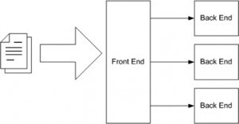

One project involved producing a number of designs, which were quite important to the success of the project. A young designer on the project team created the designs. Although the head of the design department

had ultimate responsibility for the designs, he never attended the meetings of the project team when the designs were to be discussed. The project leader always invited him, and sent him e-mails containing his young colleague’s sketches, but the e-mails remained unanswered. The project leader and the young designer erroneously assumed that the department head had approved the designs. The implementation phase began. When the project was nearly finished, the result was presented to the department head, who became furious and demanded that it be completely redone. The budget, however, was almost exhausted.

### External Design:

External design consists of conceiving, planning out and specifying the externally observable characteristics of the software product.

These characteristics include user displays and user interface forms and the report formats, external data sources and the functional characteristics, performance requirement etc. External design begins during phase and continues into the design phase.

### Logical Design:

The logical design of a system pertains to an abstract representation of the data flows, inputs and outputs of the system. This is often conducted via modelling, using an over-abstract (and sometimes graphical) model of the actual system. In the context of systems, designs are included. Logical design includes entity-relationship diagrams (ER diagrams).

### Physical Design:

The physical design relates to the actual input and output processes of the system. This is explained in terms of how data is input into a system, how it is verified/authenticated, how it is processed, and how it is displayed. In physical design, the following requirements about the system are decided.

* 1. Input requirement,
  2. Output requirements,
  3. Storage requirements,
  4. Processing requirements,
  5. System control and backup or recovery.

Put another way, the physical portion of system design can generally be broken down into three sub-tasks:

1. User Interface Design
2. Data Design

### Source Codeof Image Editor Interface:

<!DOCTYPE html>

<html dir="ltr" lang="en-US">

<head>

<meta http-equiv="Content-Type" content="text/html; charset=utf-8" />

<meta http-equiv="x-ua-compatible" content="IE=edge" />

<title>miniPaint - image editor</title>

<meta name="description" content="miniPaint is free online image editor using HTML5.

Edit, adjust your images, add effects online in your browser, without installing anything..." />

<meta name="keywords" content="photo, image, picture, transparent, layers, free, edit, html5, canvas, javascript, online, photoshop, gimp, effects, sharpen, blur, magic wand tool, clone tool, rotate, resize, photoshop online, online tools, tilt shift, sprites, keypoints" />

<meta name="viewport" content="width=device-width, initial-scale=1" />

<link rel="shortcut icon" href="images/favicon.png?v2" />

<!-- Google -->

<metaitemprop="name" content="miniPaint" />

<metaitemprop="description" content="miniPaint is free online image editor using HTML5. Edit, adjust your images, add effects online in your browser, without installing anything..." />

<metaitemprop="image" content=["ht](http://viliusle.github.io/miniPaint/images/preview.jpg)t[p://viliusle.github.io/miniPaint/images/preview.jpg"](http://viliusle.github.io/miniPaint/images/preview.jpg)

/>

<!-- Twitter -->

<meta name="twitter:card" content="summary_large_image" />

<meta name="twitter:title" content="miniPaint" />

<meta name="twitter:description" content="miniPaint is free online image editor using

HTML5. Edit, adjust your images, add effects online in your browser, without installing anything..." />

<meta name="twitter:image" content=["ht](http://viliusle.github.io/miniPaint/images/preview.jpg)t[p://viliusle.github.io/miniPaint/images/preview.jpg"](http://viliusle.github.io/miniPaint/images/preview.jpg) />

<meta name="twitter:image:alt" content="miniPaint is free online image editor using HTML5. Edit, adjust your images, add effects online in your browser, without installing anything..." />

<!-- Facebook, Pinterest -->

<meta property="og:title" content="miniPaint" />

<meta property="og:type" content="article" />

<meta property="og:url" content=["ht](http://viliusle.github.io/miniPaint/)t[p://viliusle.github.io/miniPaint/](http://viliusle.github.io/miniPaint/)" />

<meta property="og:image" content=["ht](http://viliusle.github.io/miniPaint/images/preview.jpg)t[p://viliusle.github.io/miniPaint/images/preview.jpg"](http://viliusle.github.io/miniPaint/images/preview.jpg) />

<meta property="og:description" content="miniPaint is free online image editor using HTML5. Edit, adjust your images, add effects online in your browser, without installing anything..." />

<meta property="og:site_name" content="miniPaint" />

<scriptsrc="dist/bundle.js"></script>

</head>

<body>

<div class="wrapper">

<div class="submenu">

<a class="logo" href="">miniPaint</a>

<div class="block attributes" id="action_attributes"></div>

<div class="clear"></div>

</div>

<div class="sidebar_left" id="tools_container"></div>

<div class="main_wrapper" id="main_wrapper">

<div class="canvas_wrapper" id="canvas_wrapper">

<div id="mouse"></div>

<div class="transparent-grid" id="canvas_minipaint_background"></div>

<canvas id="canvas_minipaint">

is not enabled.

<div class="trn error">

Your browser does not support canvas or JavaScript

</div>

</div>

</div>

</canvas>

<div class="sidebar_right">

<div class="preview block">

<h2 class="trn toggle" data- target="toggle_preview">Preview</h2>

<div id="toggle_preview"></div>

</div>

<div class="colors block">

<h2 class="trn toggle" data-target="toggle_colors">Colors</h2>

<input

</div>

title="Click to change color" type="color" class="color_area" id="main_color" value="#0000ff" />

<div class="content" id="toggle_colors"></div>

<div class="block" id="info_base">

<h2 class="trn toggle toggle-full" data- target="toggle_info">Information</h2>

<div class="content" id="toggle_info"></div>

</div>

<div class="details block" id="details_base">

<h2 class="trn toggle toggle-full" data- target="toggle_details">Layer details</h2>

<div class="content" id="toggle_details"></div>

</div>

<div class="layers block">

<h2 class="trn">Layers</h2>

<div class="content" id="layers_base"></div>

</div>

</div>

</div>

<div class="mobile_menu">

<button class="right_mobile_menu" id="mobile_menu_button" type="button"></button>

</div>

<div class="ddsmoothmenu" id="main_menu"></div>

<div class="hidden" id="tmp"></div>

<div id="popup"></div>

</body>

</html>

**JavaScript Code for Animation tool :**

importconfig from './../config.js'; importBase_tools_class from './../core/base-tools.js'; importBase_layers_class from './../core/base-layers.js'; importGUI_tools_class from './../core/gui/gui-tools.js'; importBase_gui_class from './../core/base-gui.js';

importBase_selection_class from './../core/base-selection.js'; importalertify from './../../../node_modules/alertifyjs/build/alertify.min.js';

var instance = null;

classAnimation_class extends Base_tools_class {

constructor(ctx) {

super();

this.Base_layers = new Base_layers_class(); this.GUI_tools = new GUI_tools_class(); this.Base_gui = new Base_gui_class(); this.name = 'animation';

this.intervalID = null; this.index = 0;

this.disable_selection(ctx);

}

load() {

//nothing

}

render(ctx, layer) {

//nothing

}

/**

* disable_selection

*/ disable_selection(ctx){

varsel_config = {

enable_background: false, enable_borders: false, enable_controlls: false, data_function: function () {

return null;

},

};

this.Base_selection = new Base_selection_class(ctx, sel_config, this.name);

}

on_params_update() {

varparams = this.getParams(); if (config.layers.length == 1) {

alertify.error('Can not animate 1 layer.'); return;

}

if (params.play == true) { this.start(params.delay);

}

else {

}

}

this.stop();

on_leave() {

this.stop();

}

start(delay) {

var _this = this;

delay = parseInt(delay); if (delay < 0)

delay = 50;

this.intervalID = window.setInterval(function () {

_this.play(_this);

}, delay);

}

stop() {

varparams = this.getParams(); if (this.intervalID == null)

return;

clearInterval(this.intervalID); params.play = false; this.index = 0;

this.GUI_tools.show_action_attributes();

//make all visible

for (var i in config.layers) { config.layers[i].visible = true;

}

this.Base_gui.GUI_layers.render_layers(); config.need_render = true;

}

play(_this) {

for (var i in config.layers) { config.layers[i].visible = false;

}

//show 1

if (config.layers[this.index] != undefined) {

_this.Base_layers.toggle_visibility(config.layers[this.index].id);

}

//change index

if (config.layers[this.index + 1] != undefined) { this.index++;

}

else {

}

}

};

this.index = 0;

export default Animation_class;

}

### Screenshots of Image Editor:

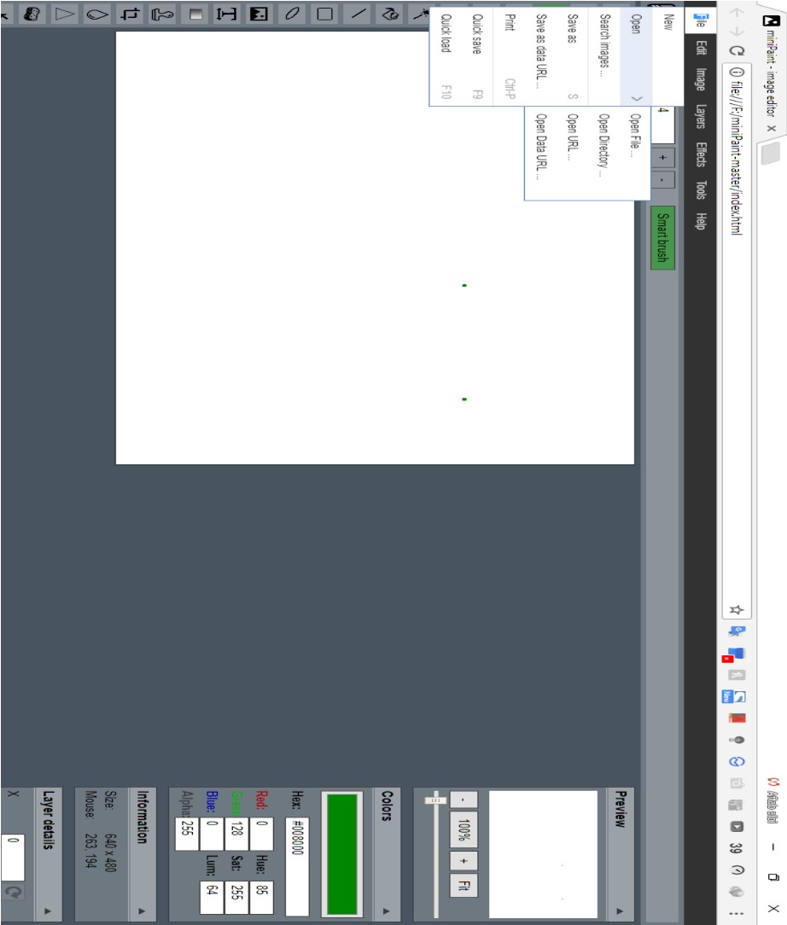

**Menu Strip to Insert, Open, Save and Print a Image:**

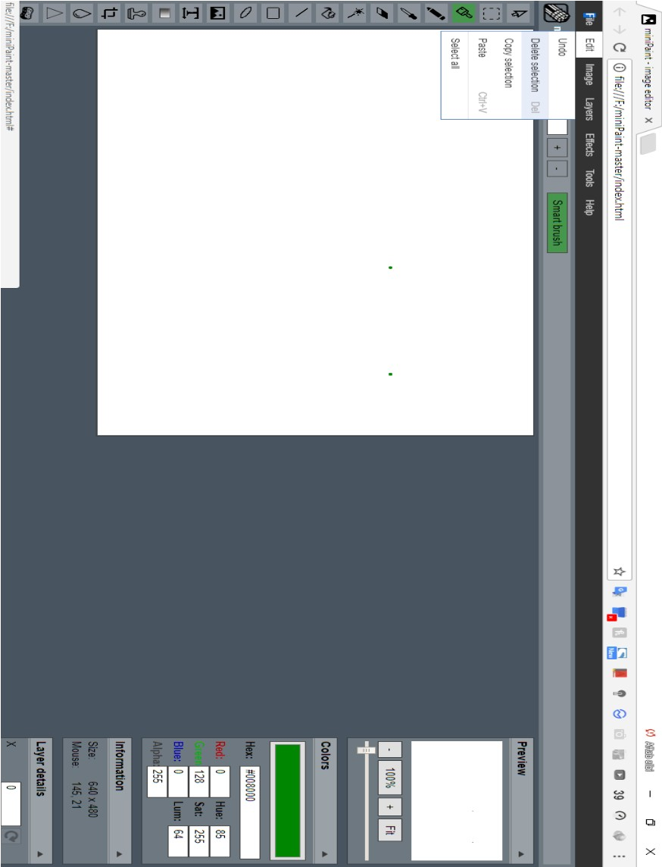

### Edit Menu strip to Cut, copy, paste and delete a image:

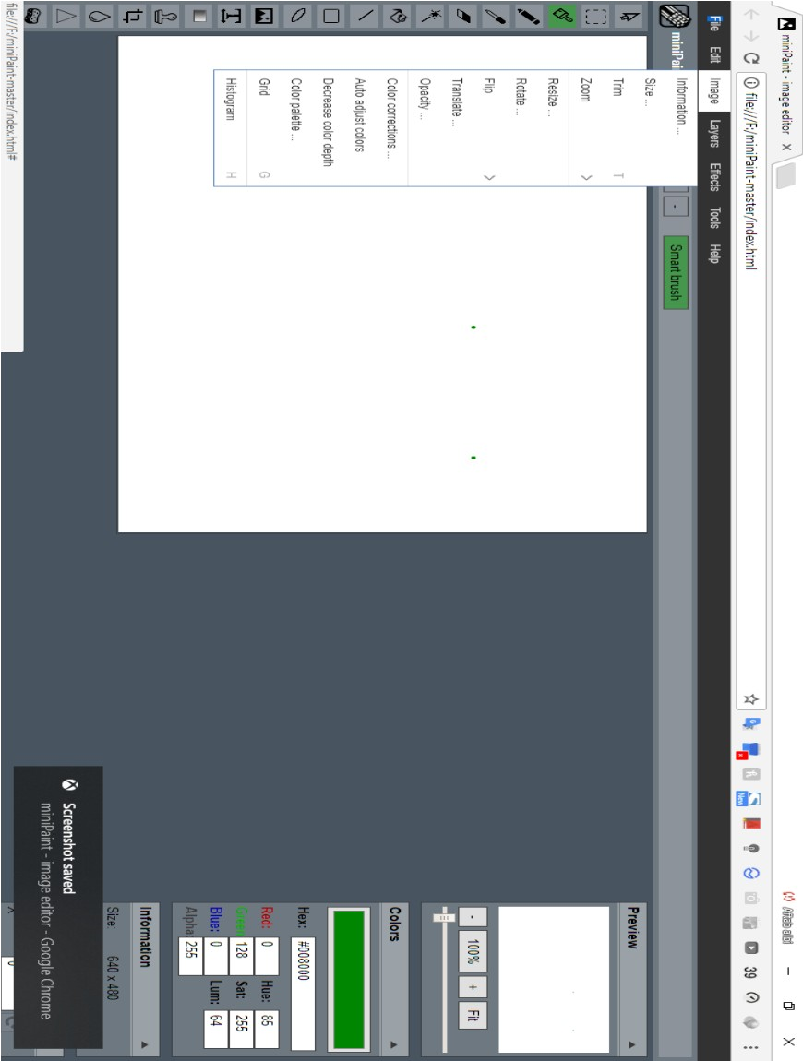

**Image menu stripe to resize, crop, flip and rotate image:**

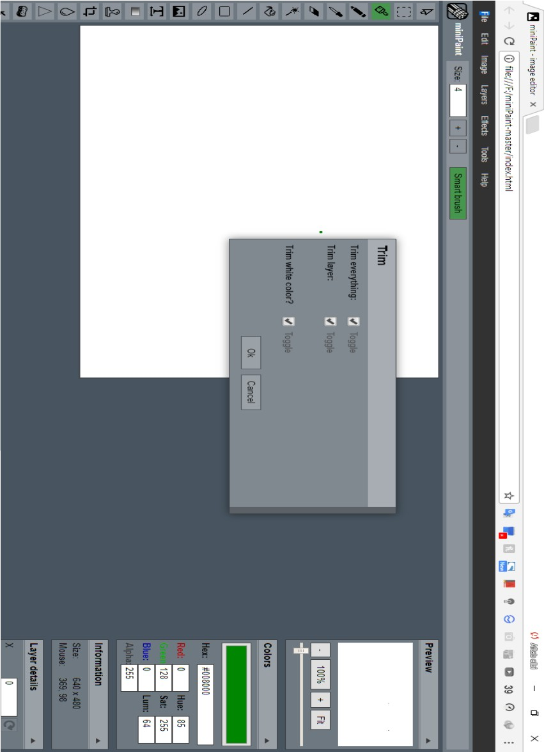

### Using of Trimming tool:

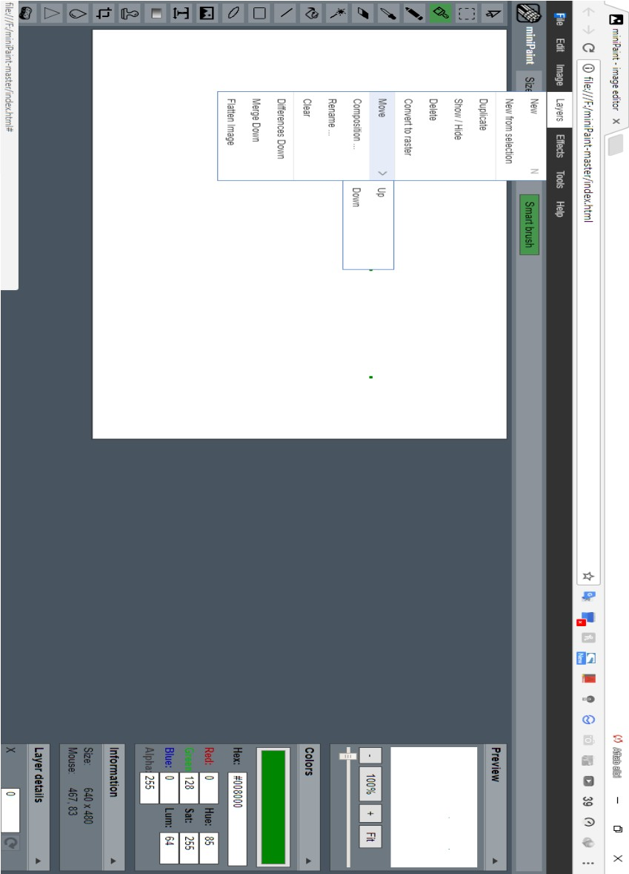

**Menu Strip to applying Layers tool to a Image:**

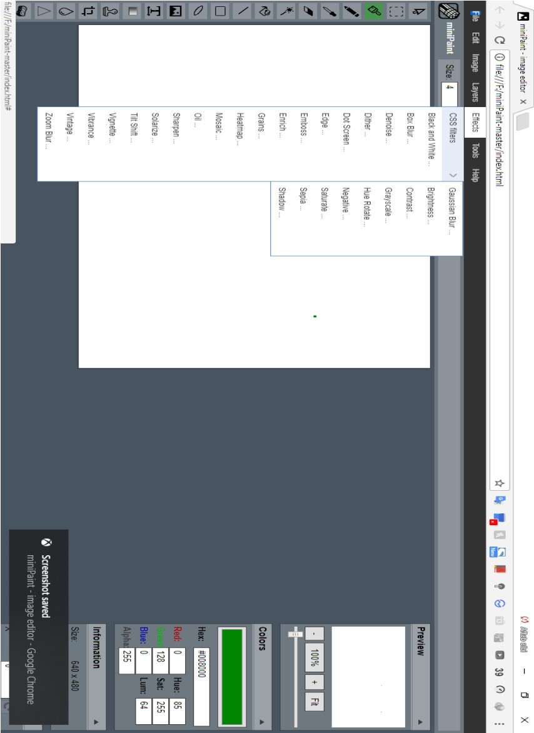

### Menu Strip to apply various Effects to a Image:

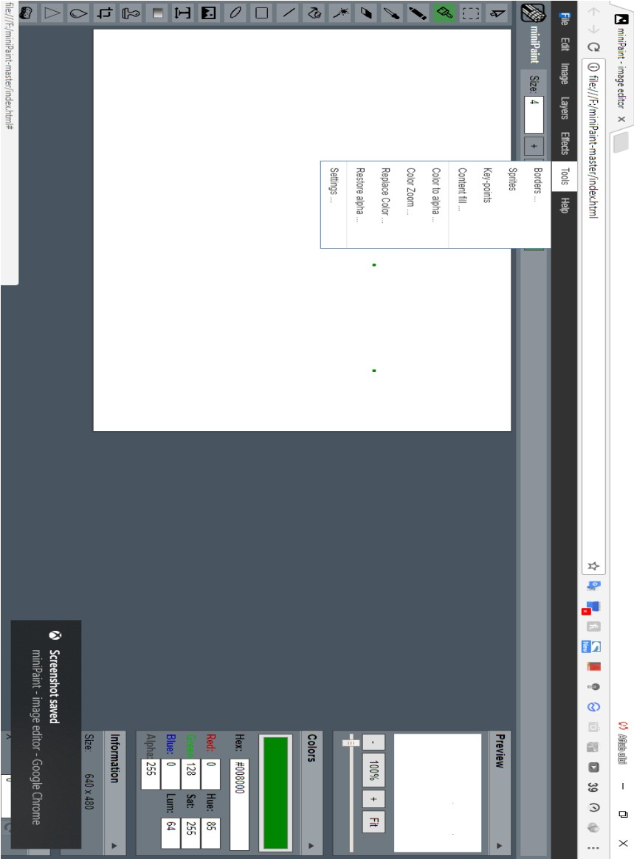

**Menu Strip to change color, border and other tools:**

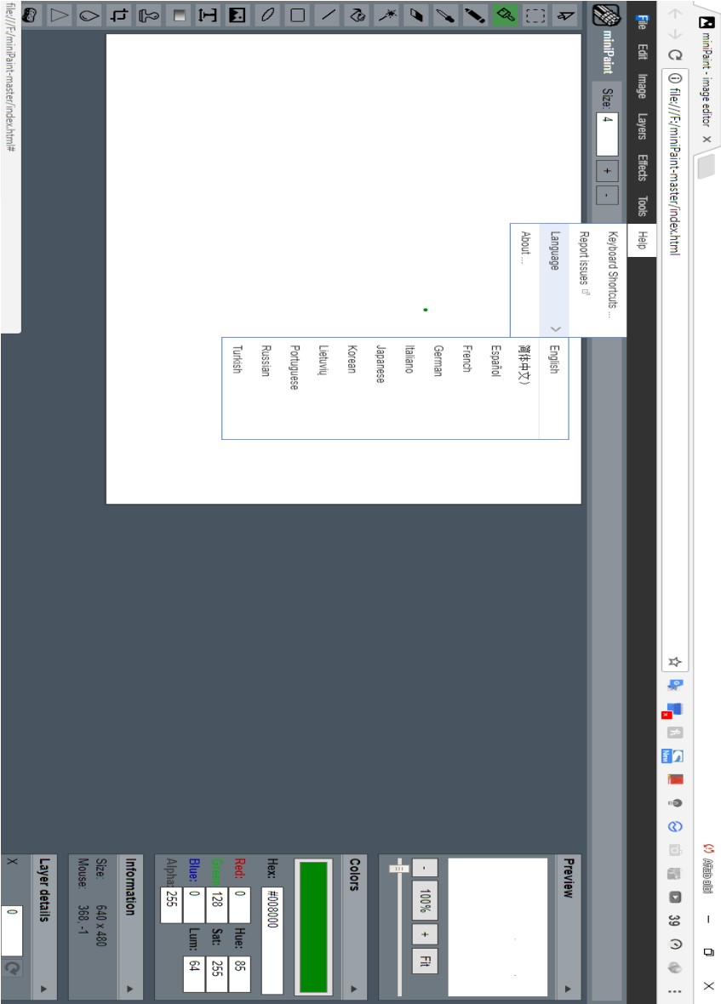

### Menu Strip related to Help request:

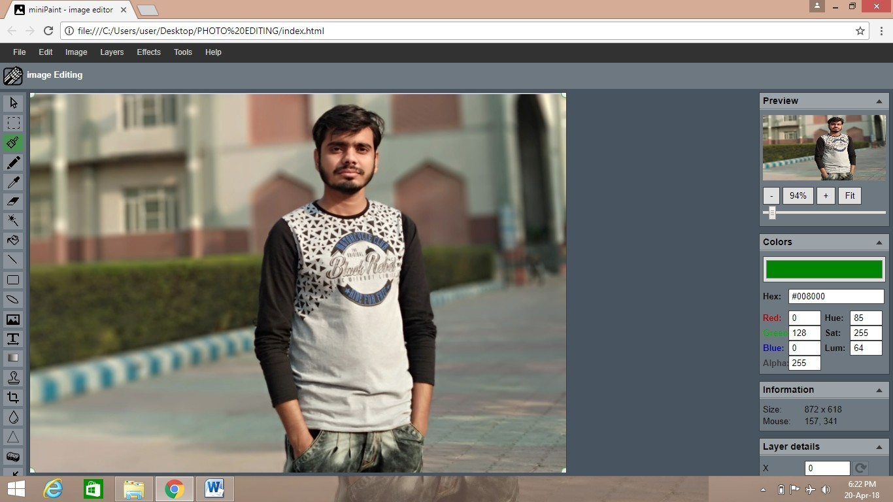

**Editor tool to Resize an image:**

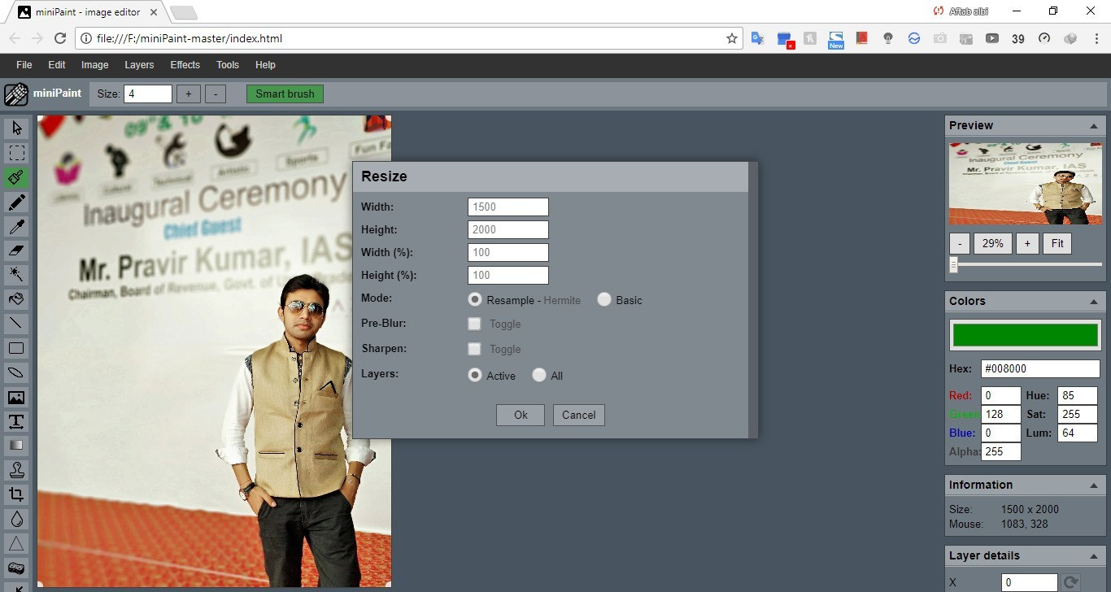

**Editor tool to Resize an image:**

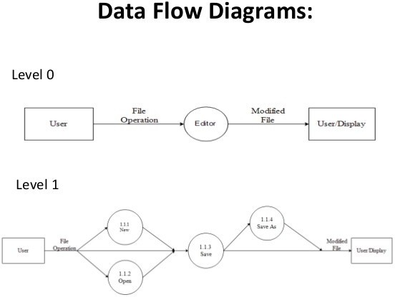

# Conclusion and Future Scope

The “ONLINE Image Editing” software very useful and advantageous app. It contain a lot of filters and effect which helps a professional to perform various type of operation on an image using several tools.

It provide a lot of features and tools to illustrate and enhance an image and can be perform artistic operation using painting and sketching tools. It also provides resizing and cropping of Image using crop and resize tool.

So,it is a combination several different types of tools which helps you to work on your image to apply different filters and effect in order to enhance the image quality.

I have tried my best to complete the project work successfully, amidst a learning environment with constant co-operation and remarkable guidance. The technique and opinions must be tuned to work well in different software development environment.

In future, the developed software will be enhanced more as required and needs of the university. Many more features will be developed and make the softwareup to the mark and fulfill all the requirement of the university.

# References

### Designing and Implementation purpose:

* Software Engineering: Apracticenersapproach by Roger S. Pressman
* System Analysis and Design by Elias M. Ewad

### Reference Site:

#### [www.m.wikipedia.com](http://www.m.wikipedia.com/)

* [**www.projects.org**](http://www.projects.org/)